Technical report on analysis, design, and implantation of mineral database

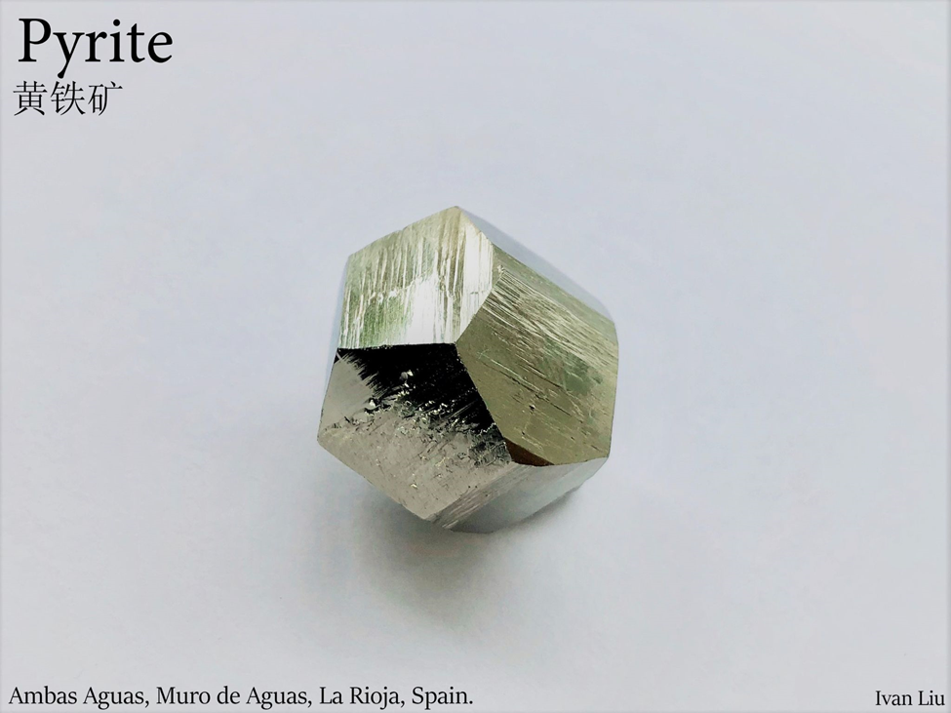

Jiangteng Liu 1000099601

27/05/2021

Table of content

1 Design Analysis and Use Cases 3

2 ENTITIES AND ATTRIBUTES 4

3 THE DATA DICTIONARY 7

4 Entity Relationship Diagram 18

5 Implementation 19

Technical report on analysis, design, and implantation of mineral database

The introduction of the report will be on user stories and use cases.

# Design Analysis and Use Cases

During my database proposal, I choose a topic about minerals. My initial idea is about helping collectors to identify their mineral and its locality. So, based on this, I choose a lot of entities that indicate the properties of minerals. For example, minerals’ physical and chemical properties, their optical data, photos and the localities.

Because I limited my database as a tool to gain information only on the properties of minerals, so things like mineral store, mineral museums, and time and locations of mineral conventions will not be in the scope of my project. Basically, the database is only design for academic uses.

**Use-cases**

* User able to see the general information of the mineral
* User is able to see the uploader of a photo
* User is able to see the location of the photos
* User is able to know what color each mineral may have

As a user, I want to able to view a mineral’s photos base on its localities so I know where it is from.

Users

* Able to add new locality and its detail
* Able to see his profile with his upload history

As a user, I want to able to input the locality and the detail of the photo so other users will know the specimen’s locality.

As a user, I want to able to add new locality into the database so other user can know about this location.

As a user, I want to have a profile so I can see the history of my uploaded photos.

Mineral information

* Able to search the details of minerals by its name
* A mineral’s information will be divided into different sections base on different properties

As a user, I want be able to search the detail of the mineral by its name so I can see the mineral information.

As a user, I want to able to see different information are separate into different section, so it is easier for me to gain the information.

After we have discussed the user stories and use case, next I will start to create the entities and attributes.

# ENTITIES AND ATTRIBUTES

First, I will need to list all the entities. There, I separate the database into 7 entities.

* **General information about the mineral**

**Mineral name (Primary key string)**

Formula

Hardness

Specific gravity

Crystal system

Type locality (Location of the minerals when they first being discover.)

* **Physical properties**

**Mineral name (Foreigner key string)**

Luster (String)

Transparency (String)

Color (String)

Streak (String)

Hardness (Float)

Tenacity (String)

Cleavage (String)

Fracture (String)

Specific gravity (float)

Radioactivity (String)

Luminescent (String)

Electromagnetism (String)

* **Chemical properties**

**Mineral name (Foreigner key string)**

Formula (String)

Common Impurities (String)

* **Crystallography**

**Mineral name (Foreigner key String)**

Crystal system (String)

Cell Parameters (float)

Morphology (Block)

Twinning (String)

* **User**

**User name (String Primary key)**

**User upload picture ID (Integer foreigner key)**

* **Photo**

**Photo ID (Integer Primary key)**

**Location ID (Integer foreigner key)**

**User name (String Foreigner key)**

**Photo(blob)**

**Dimension(text)**

* **Location**

**Locality ID (integer Primary key)**

**Location(text)**

**Countries(text)**

I have also identified the attributes and its type, and including the primary and foreigner keys in each entity. I have removed the optical data entity and also some of the attributes from crystallography. This is largely because these measurements can not or having being done on most mineral.

I have also added a entity called the “general information of mineral”, the reason for this is to avoid to duplicate identical primary key, in this case is the mineral name.

# THE DATA DICTIONARY

Table data dictionary for mineral table

|  |  |  |  |  |  |
| --- | --- | --- | --- | --- | --- |
| Entity Name | Entity Description | | | | |
| Mineral | Mineral general information. This table is related cell_parameters_and_morphology  cleavage photo  colour photo_mineral radioactivity_and_electromagnetism  common_impurities streak_and_tenacity  fracture transparency  twining  luminescent colour ID  lustre | | | | |
| Field Name | Description | Datatype | Key Field | Constraints | Example |
| mineral_name | Unique ID | Text | PK | Unique, not NULL | pyrite |
| Mineral_formula | Chemical formula symbol | text |  |  | FeS |
| Crystal_system | System name | text |  |  | trigonal |
| Streak_color_ID | From colour_ID table | Integer | FK |  | 1 |
| Maximum_hardness | number | real |  |  | 6.5 |
| minimum_hardness | number | real |  |  | 4 |
| maximum_specific_gravity | number | real |  |  | 7.7 |
| minimum_specific_gravity real | number | real |  |  | 14 |
| tenacity | English description | Text |  |  | brittle |

Table data dictionary for Cell parameters and morphology

|  |  |  |  |  |  |
| --- | --- | --- | --- | --- | --- |
| Entity Name | Entity Description | | | | |
| cell_parameters_and_morphology | Cell parameters and morphology  Relate to mineral | | | | |
| Field Name | Description | Datatype | Key Field | Constraints | Example |
| morphology | Description of mineral | text |  |  | Typically cubic or pyritohedral. |
| Mineral name | Name  From mineral table | text | FK | Not NULL | pyrite |
| a | Cell length | real |  |  | 2.8 |
| b | Cell length | real |  |  | 1.88 |
| c | Cell length | real |  |  | 5.768 |

Table data dictionary for lustre ID

|  |  |  |  |  |  |
| --- | --- | --- | --- | --- | --- |
| Entity Name | Entity Description | | | | |
| lustre_ID | lustre_ID relate to lustre | | | | |
| Field Name | Description | Datatype | Key Field | Constraints | Example |
| lustre_ID | Unique ID | Auto Integer | PK | Unique, not NULL | 1 |
| lustre | Mineral’s lustre | Text |  | Not NULL, unique | metallic |

Table data dictionary for lustre

|  |  |  |  |  |  |
| --- | --- | --- | --- | --- | --- |
| Entity Name | Entity Description | | | | |
| lustre | Mineral lustre, relate to mineral and lustre_ID | | | | |
| Field Name | Description | Datatype | Key Field | Constraints | Example |
| mineral_name | Mineral name from mineral table | text | FK | not NULL | pyrite |
| Lustre_ID | Umber from lustre_ID table | integer | FK | Not NULL | 1 |

Table data dictionary for colour ID

|  |  |  |  |  |  |
| --- | --- | --- | --- | --- | --- |
| Entity Name | Entity Description | | | | |
| Colour_ID | colour_ID relate to mineral and colour | | | | |
| Field Name | Description | Datatype | Key Field | Constraints | Example |
| Colour_ID | Unique ID | Auto Integer | PK | Unique, not NULL | 1 |
| colour | Mineral colour | text |  | Not NULL, unique | yellow |

Table data dictionary for colour

|  |  |  |  |  |  |
| --- | --- | --- | --- | --- | --- |
| Entity Name | Entity Description | | | | |
| Colour | Mineral colour, relate to mineral and colour_ID | | | | |
| Field Name | Description | Datatype | Key Field | Constraints | Example |
| Mineral_name | Mineral name from mineral table | text | FK | not NULL | pyrite |
| Colour_ID | ID from colour_ID table | integer | FK | Not NULL | 1 |

Table data dictionary for mineral common impurities

|  |  |  |  |  |  |
| --- | --- | --- | --- | --- | --- |
| Entity Name | Entity Description | | | | |
| common_impurities | Mineral common impurities, relate to mineral | | | | |
| Field Name | Description | Datatype | Key Field | Constraints | Example |
| Mineral_name | Mineral name from mineral table | text | FK | not NULL | pyrite |
| impurities | impurities | text |  |  | Cr |

Table data dictionary for mineral luminescent

|  |  |  |  |  |  |
| --- | --- | --- | --- | --- | --- |
| Entity Name | Entity Description | | | | |
| luminescent | Mineral luminescent type and colour | | | | |
| Field Name | Description | Datatype | Key Field | Constraints | Example |
| Mineral_name | Mineral name from mineral table | text | FK | not NULL | pyrite |
| Colour_ID | ID from colour_ID table | integer | FK |  | 1 |
| luminescent_description | Luminescent type | Date |  |  | Fluorescent under UV |

Table data dictionary for fracture ID

|  |  |  |  |  |  |
| --- | --- | --- | --- | --- | --- |
| Entity Name | Entity Description | | | | |
| fracture_ID | fracture_ID relate to fracture | | | | |
| Field Name | Description | Datatype | Key Field | Constraints | Example |
| fracture_ID | Unique ID | Auto Integer | PK | Unique, not NULL | 1 |
| fracture | Mineral fracture | text |  | Not NULL, unique | conchoidal |

Table data dictionary for fracture

|  |  |  |  |  |  |
| --- | --- | --- | --- | --- | --- |
| Entity Name | Entity Description | | | | |
| fracture | Mineral fracture, relate to mineral and fracture_ID | | | | |
| Field Name | Description | Datatype | Key Field | Constraints | Example |
| Mineral_name | Mineral name from mineral table | text | FK | not NULL | pyrite |
| fracture_ID | ID from fracture_ID table | integer | FK | Not NULL | 1 |

Table data dictionary for cleavage ID

|  |  |  |  |  |  |
| --- | --- | --- | --- | --- | --- |
| Entity Name | Entity Description | | | | |
| cleavage_ID | cleavage_ID relate to mineral cleavage | | | | |
| Field Name | Description | Datatype | Key Field | Constraints | Example |
| cleavage_ID | Unique ID | Auto Integer | PK | Unique, not NULL | 1 |
| cleavage | Mineral cleavage | text |  | Not NULL, unique | poor |

Table data dictionary for cleavage

|  |  |  |  |  |  |
| --- | --- | --- | --- | --- | --- |
| Entity Name | Entity Description | | | | |
| cleavage | Mineral cleavage, relate to mineral and fracture_ID | | | | |
| Field Name | Description | Datatype | Key Field | Constraints | Example |
| Mineral_name | Mineral name from mineral table | text | FK | not NULL | pyrite |
| cleavage_ID | ID from cleavage_ID table | integer | FK | Not NULL | 1 |
| miller_indices | number | integer |  |  | 001 |

Table data dictionary for radioactivity and electromagnetism

|  |  |  |  |  |  |
| --- | --- | --- | --- | --- | --- |
| Entity Name | Entity Description | | | | |
| radioactivity_and_electromagnetism | Radioactivity and electromagnetism of minerals, relate to mineral. | | | | |
| Field Name | Description | Datatype | Key Field | Constraints | Example |
| Mineral_name | Mineral name from mineral table | text | FK | not NULL | pyrite |
| Radioactivity | Radioactivity of minerals | Text |  |  | yes |
| electromagnetism | Electromagnetism of minerals | Text |  |  | yes |

Table data dictionary for mineral transparency

|  |  |  |  |  |  |
| --- | --- | --- | --- | --- | --- |
| Entity Name | Entity Description | | | | |
| transparency | Transparency of minerals, relate to minerals | | | | |
| Field Name | Description | Datatype | Key Field | Constraints | Example |
| Mineral_name | Mineral name from mineral table | text | FK | not NULL | pyrite |
| transparency | Transparency of minerals | text |  | Not NULL | opaque |

Table data dictionary for twining ID

|  |  |  |  |  |  |
| --- | --- | --- | --- | --- | --- |
| Entity Name | Entity Description | | | | |
| twining_ID | twining_ID relate to mineral twining | | | | |
| Field Name | Description | Datatype | Key Field | Constraints | Example |
| twining_ID | Unique ID | Auto Integer | PK | Unique, not NULL | 1 |
| twining | Mineral twining | text |  | Not NULL, unique | interpenetrating |

Table data dictionary for twining

|  |  |  |  |  |  |
| --- | --- | --- | --- | --- | --- |
| Entity Name | Entity Description | | | | |
| twining | Mineral twining, relate to mineral and twining_ID | | | | |
| Field Name | Description | Datatype | Key Field | Constraints | Example |
| Mineral_name | Mineral name from mineral table | text | FK | not NULL | pyrite |
| twining_ID | ID from twining_ID table | Integer | FK | not NULL | 1 |
| Twining_name | name | text |  |  | Iron Cross Law |
| miller_indices | number | integer |  |  | 110 |

Table data dictionary for photo ID

|  |  |  |  |  |  |
| --- | --- | --- | --- | --- | --- |
| Entity Name | Entity Description | | | | |
| Photo_ID | Mineral photos, relate to user_ID, and location_ID | | | | |
| Field Name | Description | Datatype | Key Field | Constraints | Example |
| photo_ID | Unique ID | Auto Integer | PK | Unique, not NULL | 1 |
| user_ID | Name from user_ID table | text | FK | not NULL | Tovano |
| photo | image | blob |  | Not null |  |
| location_ID | ID from location_ID table | integer | FK |  | 1 |
| dimension | Dimension of mineral | text |  |  | 3cm x 2cm x 1cm |

Table data dictionary for photos and minerals

|  |  |  |  |  |  |
| --- | --- | --- | --- | --- | --- |
| Entity Name | Entity Description | | | | |
| photo_mineral | Interconnect photos and minerals relate to twining_ID and photo_ID and mineral | | | | |
| Field Name | Description | Datatype | Key Field | Constraints | Example |
| Mineral_name | Mineral name from mineral table | text | FK |  | quartz |
| photo_ID | ID from photo_ID table | integer | FK | not NULL | 1 |
| Twining_name | name | text |  |  | Japan twin law |
| Other_name | Mineral var | text |  |  | amethyst |
| twining_ID | ID from twining_ID table | Integer | FK |  | 1 |

Table data dictionary for users and photos

|  |  |  |  |  |  |
| --- | --- | --- | --- | --- | --- |
| Entity Name | Entity Description | | | | |
| User_photo | Interconnect photos and minerals relate to user_ID and photo_ID and mineral | | | | |
| Field Name | Description | Datatype | Key Field | Constraints | Example |
| user_ID | ID from user_ID table | text | FK | not NULL | Tovano |
| photo_ID | ID from photo_ID table | integer | FK | not NULL | 1 |

Table data dictionary for user ID

|  |  |  |  |  |  |
| --- | --- | --- | --- | --- | --- |
| Entity Name | Entity Description | | | | |
| User_ID | User name relate to photo_ID | | | | |
| Field Name | Description | Datatype | Key Field | Constraints | Example |
| user_ID | Unique ID | text | PK | Unique, not NULL | Tovano |

Table data dictionary for location ID

|  |  |  |  |  |  |
| --- | --- | --- | --- | --- | --- |
| Entity Name | Entity Description | | | | |
| Location_ID | location relate to photo table | | | | |
| Field Name | Description | Datatype | Key Field | Constraints | Example |
| Location_ID | Unique ID | Auto Integer | PK | Unique, not NULL | 1 |
| location | Location name | text |  | not NULL unique | karaka |
| country | Country name | text |  | Not null | New Zealand |

Next, I will be presenting the entity relationship diagram

# Entity Relationship Diagram

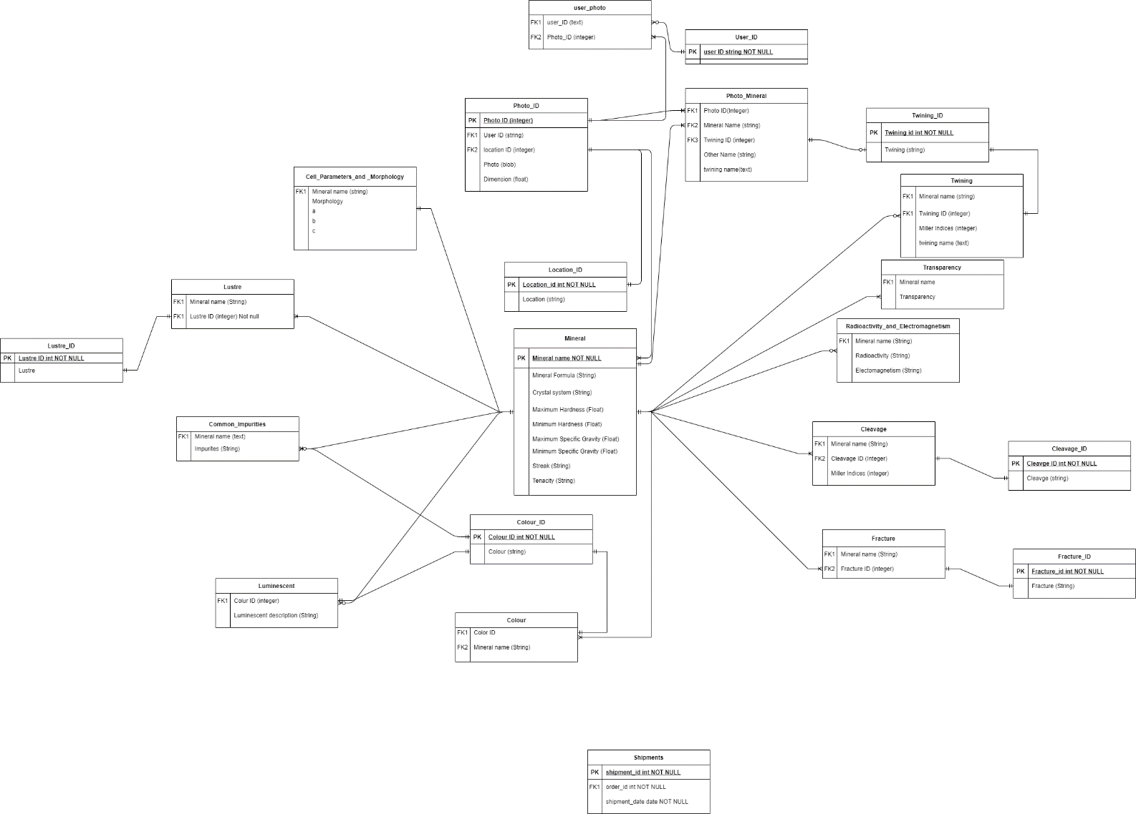

The last section of this report will be the implementation of the database.

# Implementation

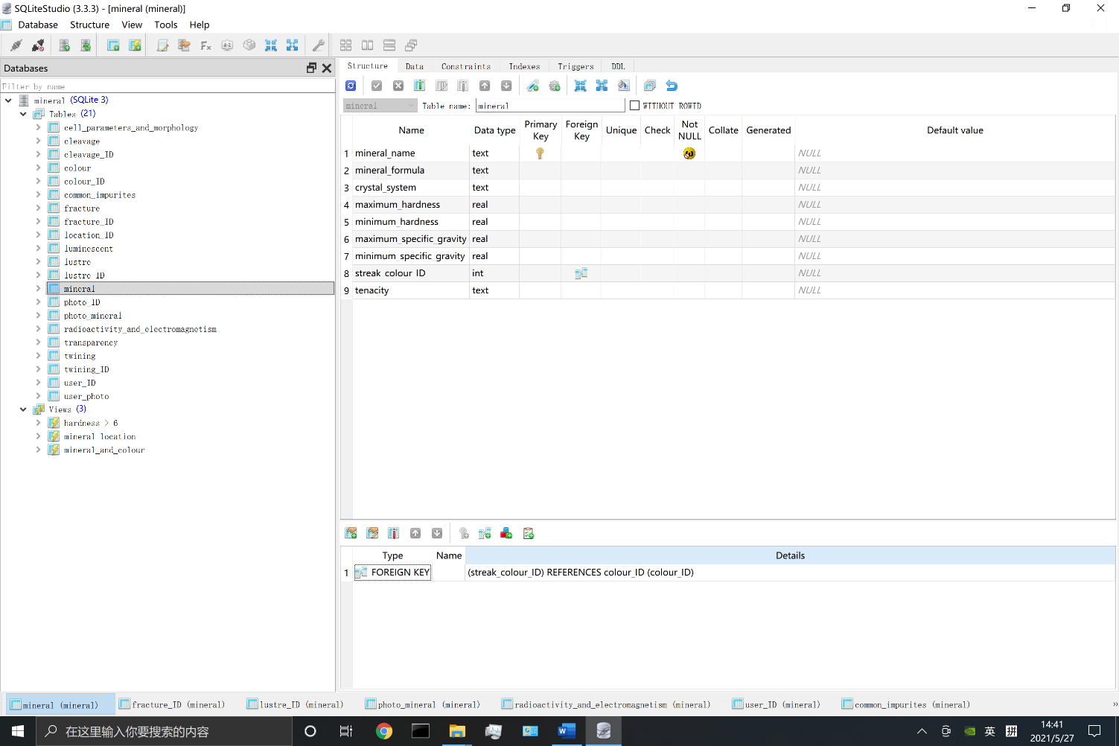

Thank your for reading this report.